



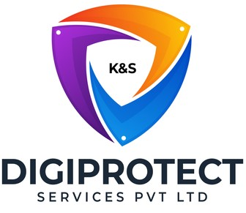

INITIAL
ASSESSMENT
REPORT

DATE: 31st May 2024
Collections & Recovery

VERSION: 1.0

Document History
Document version | Remarks | Submitted  By | Submission  Date | Approved BY | Approval  Date
1.0 | First Draft | k&S Digiprotect | 31st May 2024

K&S Digiprotect Services Pvt. Ltd.
Date of Discussion: Date of Release:
Version: 1.0
Date of Release: 15th April 2024

Table of Contents
Introduction 4
Objectives 4
General Information 5
SPOC Information 5
Department Hierarchy* 6
Observations 7
Data Flow Diagram (DFD) 10
Data Mapping and Inventory 11
Recommendations 12
Conclusion 12
Appendices 13
Appendix A 13

Introduction
India Shelter’s Collections & Recovery department is tasked with the responsibility of managing collection operations and facilitating asset recovery processes. As custodians of sensitive customer information, this department plays a pivotal role in ensuring the integrity, confidentiality, and security of data throughout various activities such as case allocation, legal proceedings, and property sales.
This report encapsulates critical insights for As-Is study, derived from the initial interview conducted with the Collections & Recovery Department of India Shelter Finance Corporation Limited (ISFC) for the implementation of ISO/IEC 27001:2022 and compliance with the Digital Personal Data Protection Act (DPDPA).
The overarching objectives of this interview were dual fold: first, to gain an understanding of the departmental structure, and second, to delve into the core operational processes of the Collections & Recovery Department. Additionally, the interview aimed to assess the existing information security practices, focusing on evaluating adherence to DPDPA requirements and the readiness for ISO/IEC 27001:2022 implementation.
By delving into the details of the department's organizational setup, operational workflows, and data handling procedures, this report aims to identify both the strengths and areas of improvement in information security management and DPDPA compliance within the department.

Objectives
- Understand the departmental hierarchy and reporting structure
- Learn the existing processes of ISFC’s Collections & Recovery Department
- Mapping of existing processes with documented processes
- Offer recommendations to optimize the existing processes

General Information
Organization Name | India Shelter Finance Corporation Limited
Department Name | Collections & Recovery
Date of the Assessment | 3rd May 2024
Location | Basement, India Shelter HQ, Gurugram
Meeting Duration | 1 hr
Attendees (ISFC) | Ajay Chhabra, Captain Vinay, Sunil Kumar Sharma
Attendees (Digiprotect) | Lalit Mohan Joshi, Adhita Razdan

SPOC Information
Project SPOC: Dheeraj Yadav
Contact Information:
Email ID: dheeraj.yadav@indiashelter.in

Project Coordinator: Sunil Kumar Sharma
Contact Information:
Email ID: sunil.sharma2@indiashelter.in

Department SPOC: Ajay Chhabra
Contact Information:
Email ID: ajay.chhabra@indiashelter.in

Department Hierarchy*

* As informed during the meeting

Observations
S. No | Key Activities | Observations and Asks | Remarks
 | Allocation of cases to Collection Officers  - Due dates for payment of EMIs are 7th, 12th, and 15th of every month.  - Bounce reports are generated on 8th, 13th, and 16th which are then allocated to the Collection Officers.  - Pending EMIs are categorized as buckets – 0-60, 61 – 90 and above. The numbers indicate the days that the EMI was not paid for.  - iCollect Application is used by collection officers.  - Collection Officers are allocated cases on the 1st of every month via the app. The allocation is automatic.  - It has the following details of a customer:  - Customer Name  - Customer Address  - Pending EMIs  - Visit to customers is captured through the app.  - The app also has a calling feature in which the number is not shown to the Collection Officers.  - All collection is done digitally. No cash receipt is generated.  - Incentives for collection officers are based on the cases resolved by them. | - Phone Numbers can be seen in history in application and can be downloaded.  - Finance Portfolio report contains personal information of customers:  - Loan ID  - Customer ID  - Customer Name  - EMI Installment details
 | Cash Collection (Special Cases only)  - Collection of cash by Branch Collection Manager, Area Collection Manager, or Branch Operations can be done with prior approval from HQ. The approvals are taken on emails.  - The amount of cash that can be collected is limited to Rs 20,000. | NA
 | Legal  - In case of non-payment of EMIs, legal route is taken by the Collections & recovery team.  - Section 138 – Customer PDC, court case  - Section 17 – Bank account attach, Lock breaking, Arbitration of Property, Broadcasting by auto, Banner display at premises  - Section 32 - Sarfaesi – Only taken when account is declared NPA. For possession of property. Possession can only be done after a court order. | NA
 | Sale of property  - Valuation of property is done by the technical team on ground and uploaded to Salesforce.  - Reserve Price for the property is decided by the Back Office team which sends it to approval for Region Head and is further sent to the HOD for final approval.  - If the reserve price is rejected, it is sent back to region head for decision of reserve price and the process continues until final HOD approval is received.  - Once the HOD approves the Reserve Price, Sale notice is issued with a 30-day limit for auction. The notice is released in newspapers of English and vernacular language within 7 days. This is done by the Back Office at HO along with the local team.  - Bid Forms are released and filled at branch offices.  - Physical Bid forms of the successful bidder are also sent to HO which are then transferred to CRC (document vendor)  - A scanned copy of the Bid Form is sent to HO via emails.  - All auctions are held offline only.  - Possession is given to H1 bidder.  - In case of loss on sale of property, a case is registered against the customer for the same.  - Upon completion of the case, information is sent to Operations and Finance team for case closure. | - Bid Forms contain Personal Information of Bidder:  - Name  - Address  - Details of DD/ Pay order  - Signature  - Mobile Number

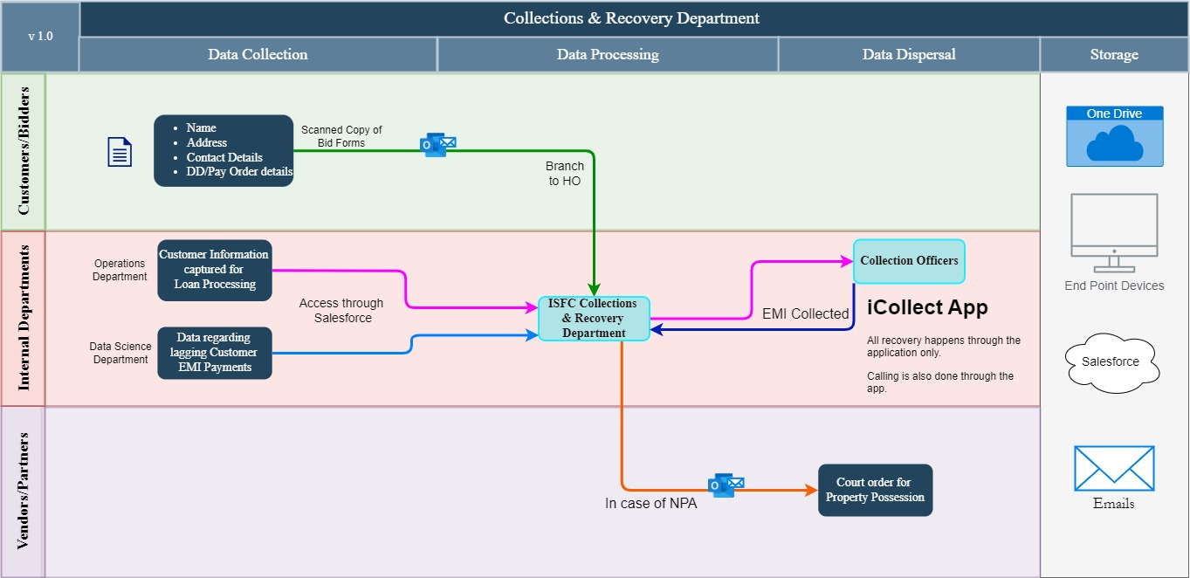
Data Flow Diagram (DFD)

Data Mapping and Inventory
S. No | Data Category | Description | Purpose | Data Owner | Storage Location | Data Classification* | Retention Period | Legal Basis
1 | Customer Details | Customer name, address, and pending EMIs | Case allocation for collections | Collections Team | iCollect App/  Salesforce/ Excel | PII/Sensitive | Not Defined | Contractual Obligation
2 | Collection Activity Records | Details of customer visits and calls made by Collection Officers | Tracking collection activities | Collections Team | iCollect App/ Salesforce | PII/Sensitive | Not Defined | Contractual Obligation
3 | Finance Portfolio Report | Loan ID, Customer ID, Customer Name, EMI installment details | Monitoring financial portfolio | Finance Team | Salesforce/ Excel/ Emails | PII/Sensitive | Not Defined | Legal Requirement
4 | Collection Incentive Records | Records of cases resolved by Collection Officers, used for calculating incentives | Incentive management | Collections/ Finance Team | HRIS/ Emails | Non PII/  Restricted | Not Defined | Employment Contract
5 | Legal Case Records | Records of legal actions taken for non-payment of EMIs | Legal enforcement and recovery | Legal /  Collections Team | Physical Copies/  Emails | PII/Sensitive | Not Defined | Legal Requirement
6 | Property Sale Records | Records related to sale of property. | Property sale management | Collections Team | Salesforce/  Emails | PII/Sensitive | Not Defined | Legal Requirement
7 | Bid Forms | Bidder information including name, address, DD/pay order details, signature, mobile number | Auction management | Collections Team | CRC/ Emails | PII/Sensitive | Not Defined | Legal Requirement
*Refer Appendix A

Recommendations
- Data Masking for Phone Numbers
- Implement data masking for customer phone numbers in the iCollect app. Ensure that phone numbers are partially obscured in history logs and reports to protect customer privacy.
- Prevent the download of phone numbers unless strictly necessary and ensure such actions are logged and monitored.

- Enhanced Security for iCollect Application
- Ensure the iCollect application employs strong encryption for data at rest and in transit. Implement multi-factor authentication (MFA) for accessing the app to enhance security.
- Regularly update the app to address any security vulnerabilities.

- Data Deletion Policies
- Define and implement data retention policies for customer details and collection activity records.
- Automatically delete or anonymize data that is no longer needed for business or legal purposes after the retention period expires.

- Secure Handling of Bid Forms
- Encrypt bid forms both in transit and at rest.
- Ensure physical bid forms are securely stored and access is restricted to authorized personnel only.

Conclusion
In conclusion, the Collections & Recovery department manages collection operations, legal enforcement, and asset recovery within the organization. Through the data inventory and observations, several key areas for improvement have been identified to enhance data privacy and information security practices.
By implementing tailored recommendations such as enhancing security measures for the iCollect application, and implementing strict access controls for legal case records and property sale data, the department can mitigate risks associated with handling sensitive customer information. A comprehensive security training plan will further strengthen the department's ability to protect data and comply with regulations.

Appendices

Appendix A
Data Classification | Definition
Sensitive Data | Information that, if disclosed, altered, or destroyed without authorization, could cause significant harm to an individual, organization, or entity. This often includes financial records, medical information, and PII.
Restricted Data | Highly sensitive data tightly controlled due to legal, regulatory, or contractual requirements. Access is limited to authorized personnel, and any unauthorized disclosure may result in severe consequences.
Private Data | Information considered confidential and intended solely for specific individuals or groups within an organization. It requires protection from unauthorized access to maintain privacy and uphold confidentiality agreements.
Confidential Data | Privileged or proprietary information of an organization requiring protection from unauthorized access, disclosure, or alteration.
Public Data | Information that is freely available and accessible to the general public without restrictions or limitations. It does not contain sensitive or confidential information and can be openly accessed and used for various purposes such as research, analysis, and public interest initiatives.
PII (Personally Identifiable Information) | Data that can identify, contact, or locate an individual, either alone or in combination with other information. For example - names, addresses, official identifiers (Aadhar, Pan, DL, biometrics, etc).
Non-PII | Data that, while not personally identifiable, however may still require protection due to its sensitivity or confidentiality. This may include corporate financial information, proprietary research data, or internal communications.

----------------------------------End of report for Collections & Recovery ------------------------------

